Ocean Patriot - Stop Card of the Week
29 April 06
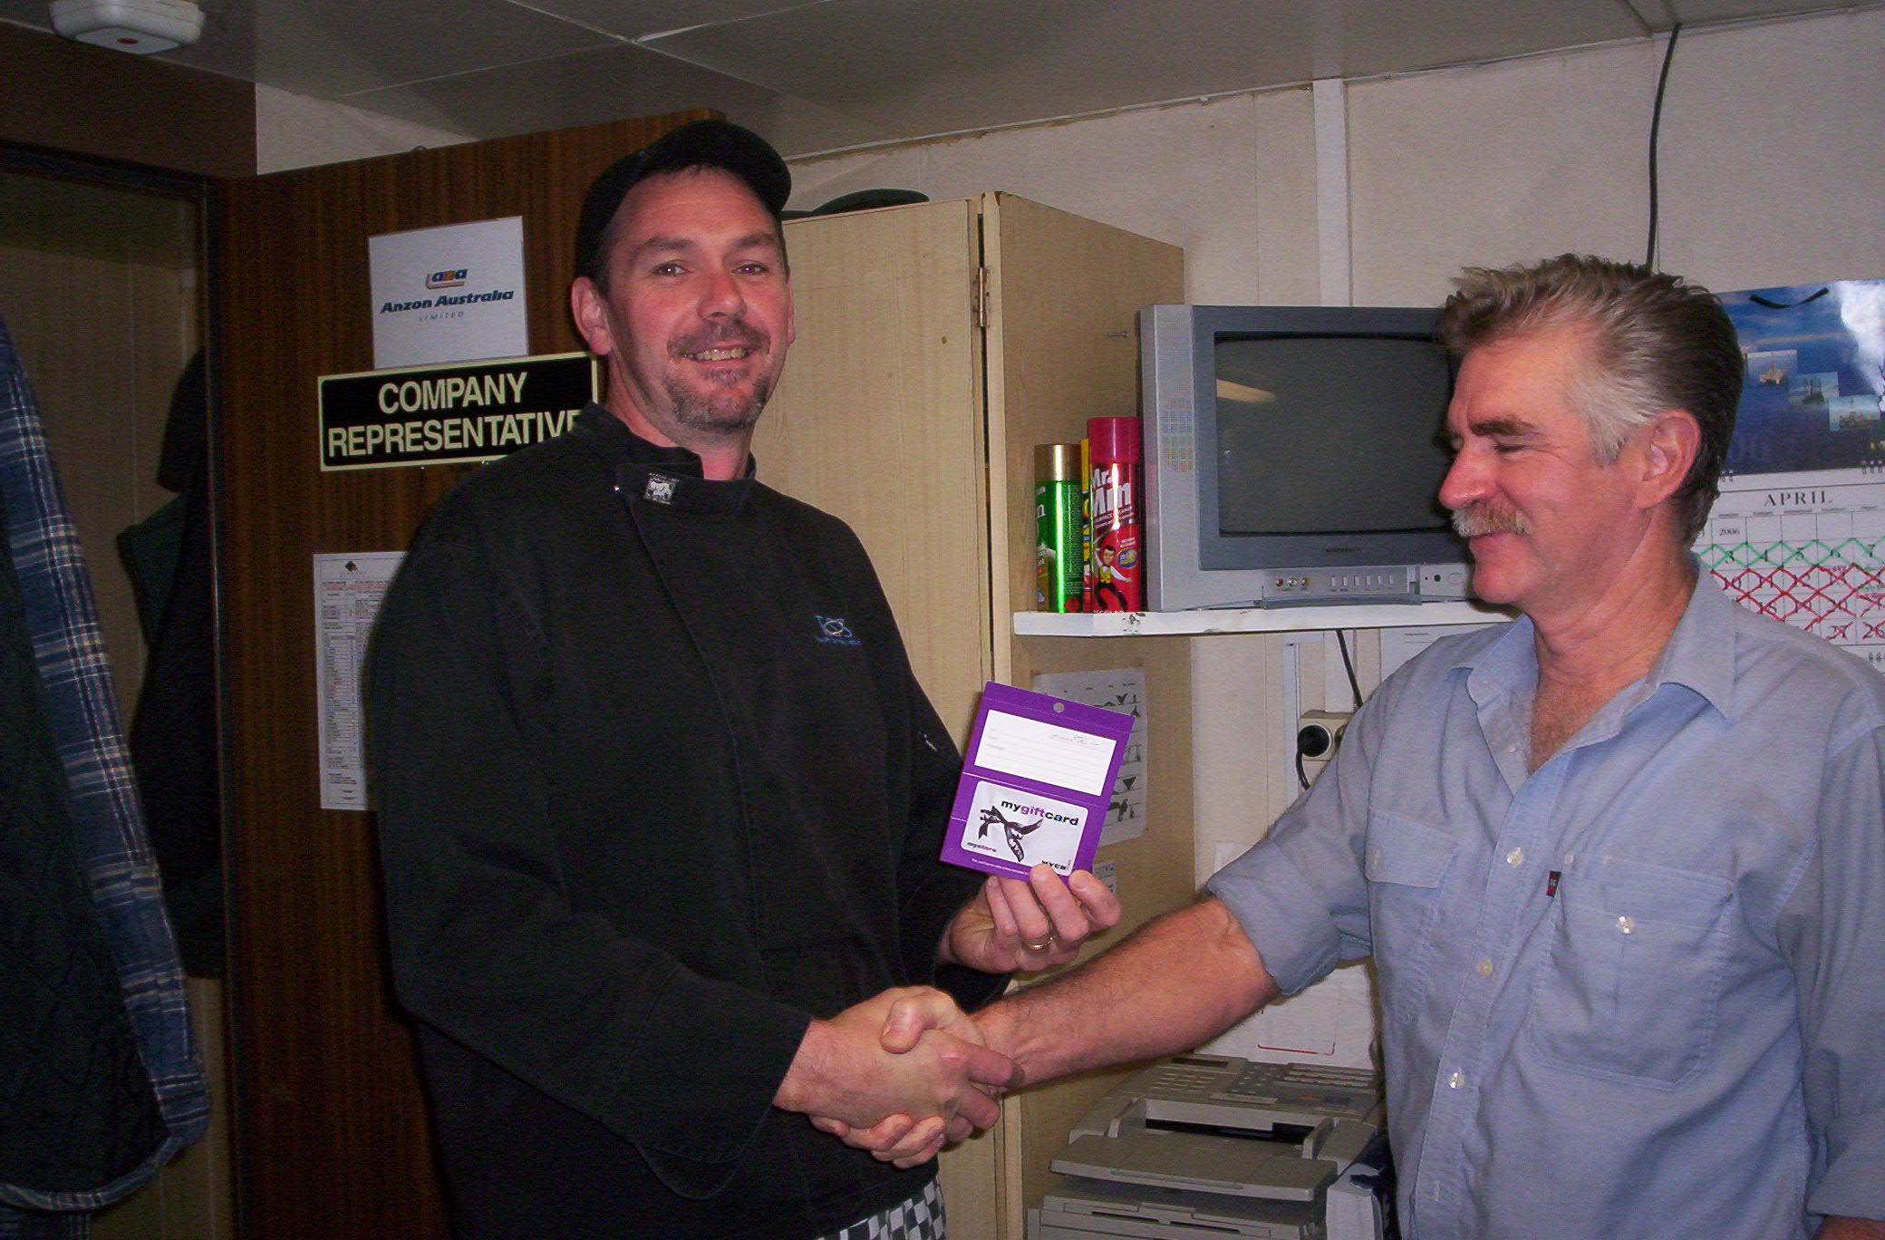

ANZON stop card of the week winner is Steve Andrews, who was fostering team spirit when he acknowledged the help given by the weatherford crew in unloading food stores at night helping to minimize repetitive back strain injury. Team work makes our work area safe for all.
Camp boss Wayne Baker accepts the award for Steve from John Forrest.

“Nobody gets Hurt” !

